***This is a bonus Web chapter

CHAPTER 36

JavaBeans

Objectives
- To describe what a JavaBeans component is (§36.2).
- To explain the similarities and differences between beans and regular objects (§36.2).
- To develop JavaBeans components that follow the naming patterns (§36.3).
- To review the Java event delegation model (§36.4).
- To create custom event classes and listener interfaces (§36.5).
- To develop source components using event sets from the Java API or custom event sets (§36.6).
36.1 Introduction
Every Java user interface class is a JavaBeans component. Understanding JavaBeans will help you to learn GUI components. In Chapter 16, “Event-Driven Programming,” you learned how to handle events fired from source components such as JButton, JTextField, JRadioButton, and JComboBox. In this chapter, you will learn how to create custom events and develop your own source components that can fire events. By developing your own events and source components, you will gain a better understanding of the Java event model and GUI components.

36.2 JavaBeans
<margin note: JavaBeans>
JavaBeans is a software component architecture that extends the power of the Java language by enabling well-formed objects to be manipulated visually at design time in a pure Java builder tool, such as NetBeans and Eclipse. Such well-formed objects are referred to as JavaBeans or simply beans. The classes that define the beans, referred to as JavaBeans components or bean components, conform to the JavaBeans component model with the following requirements:

- A bean must be a public class.
- A bean must have a public no-arg constructor, though it can have other constructors if needed. For example, a bean named MyBean must either have a constructor with the signature
public MyBean();

or have no constructor if its superclass has a no-arg constructor.
<margin note: Serializable>
- A bean must implement the java.io.Serializable interface to ensure a persistent state.
<margin note: accessor>
<margin note: mutator>
- A bean usually has properties with correctly constructed public accessor (get) methods and mutator (set) methods that enable the properties to be seen and updated visually by a builder tool.
<margin note: event registration>
- A bean may have events with correctly constructed public registration and deregistration methods that enable it to add and remove listeners. If the bean plays a role as the source of events, it must provide registration methods for registering listeners. For example, you can register a listener for ActionEvent using the addActionListener method of a JButton bean.
The first three requirements must be observed, and therefore are referred to as minimum JavaBeans component requirements. The last two requirements depend on implementations. It is possible to write a bean component without get/set methods and event registration/deregistration methods.

A JavaBeans component is a special kind of Java class. The relationship between JavaBeans components and Java classes is illustrated in Figure 36.1.

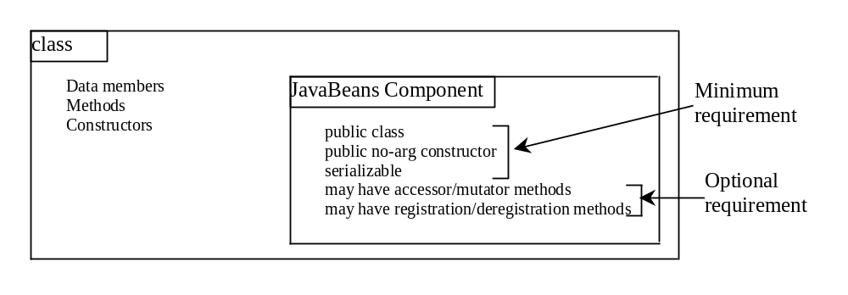

Figure 36.1
A JavaBeans component is a serializable public class with a public no-arg constructor.

Every GUI class is a JavaBeans component, because
(1) it is a public class,
(2) it has a public no-arg constructor, and
(3) It is an extension of java.awt.Component, which implements java.io.Serializable.

36.3 Bean Properties
Properties are discrete, named attributes of a Java bean that can affect its appearance or behavior. They are often data fields of a bean. For example, the JButton component has a property named text that represents the text to be displayed on the button. Private data fields are often used to hide specific implementations from the user and prevent the user from accidentally corrupting the properties. Accessor and mutator methods are provided instead to let the user read and write the properties.

36.3.1 Property-Naming Patterns
The bean property-naming pattern is a convention of the JavaBeans component model that simplifies the bean developer's task of presenting properties. A property can be a primitive data type or an object type. The property type dictates the signature of the accessor and mutator methods.

In general, the accessor method is named get<PropertyName>(), which takes no parameters and returns a primitive type value or an object of a type identical to the property type. For example,

<margin note: accessor method>
public String getMessage()
public int getXCoordinate()
public int getYCoordinate()

For a property of boolean type, the accessor method should be named is<PropertyName>(), which returns a boolean value. For example,

<margin note: boolean accessor method>
public boolean isCentered()

The mutator method should be named set<PropertyName>(dataType p), which takes a single parameter identical to the property type and returns void. For example,

<margin note: mutator method>
public void setMessage(String s)
public void setXCoordinate(int x)
public void setYCoordinate(int y)
public void setCentered(boolean centered)

NOTE
You may have multiple get and set methods, but there must be one get or set method with a signature conforming to the naming patterns.

36.3.2 Properties and Data Fields
Properties describe the state of the bean. Naturally, data fields are used to store properties. However, a bean property is not necessarily a data field. For example, in the MessagePanel class in Listing 15.7, MessagePanel.java, you may create a new property named messageLength that represents the number of characters in message. The get method for the property may be defined as follows:

public int getMessageLength() {
return message.length();
}

NOTE
<margin note: read-only property>
<margin note: write-only property>
A property may be read-only with a get method but no set method, or write-only with a set method but no get method.

36.4 Java Event Model Review
A bean may communicate with other beans. The Java event delegation model provides the foundation for beans to send, receive, and handle events. Let us review the Java event model that was introduced in Chapter 16, “Event-Driven Programming.” The Java event model consists of the following three types of elements, as shown in Figure 16.3:

- The event object
- The source object
- The event listener object

<margin note: event>
<margin note: source object>
<margin note: listener>
An event is a signal to the program that something has happened. It can be triggered by external user actions, such as mouse movements, mouse button clicks, and keystrokes, or by the operating system, such as a timer. An event object contains the information that describes the event. A source object is where the event originates. When an event occurs on a source object, an event object is created. An object interested in the event handles the event. Such an object is called a listener. Not all objects can handle events. To become a listener, an object must be registered as a listener by the source object. The source object maintains a list of listeners and notifies all the registered listeners by invoking the event-handling method implemented on the listener object. The handlers are defined in event listener interface. Each event class has a corresponding event listener interface. The Java event model is referred to as a delegation-based model, because the source object delegates the event to the listeners for processing.

36.4.1 Event Classes and Event Listener Interfaces
An event object is created using an event class, such as ActionEvent, MouseEvent, and ItemEvent, as shown in Figure 16.2. All the event classes extend java.util.EventObject. The event class contains whatever data values and methods are pertinent to the particular event type. For example, the KeyEvent class describes the data values related to a key event and contains the methods, such as getKeyChar(), for retrieving the key associated with the event.

<margin note: handler>
Every event class is associated with an event listener interface that defines one or more methods referred to as handlers. An event listener interface is a subinterface of java.util.EventListener. The handlers are implemented by the listener components. The source component invokes the listeners' handlers when an event is detected.

<margin note: event set>
Since an event class and its listener interface are coexistent, they are often referred to as an event set or event pair. The event listener interface must be named as XListener for the XEvent. For example, the listener interface for ActionEvent is ActionListener. The parameter list of a handler always consists of an argument of the event class type. Table 16.2 lists some commonly used events and their listener interfaces. Figure 36.2 shows the pair of ActionEvent and ActionListener.

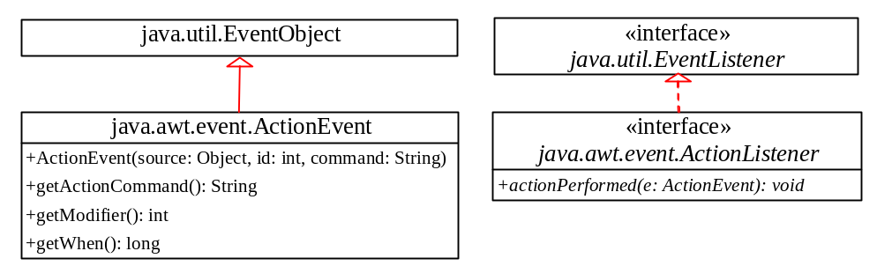

Figure 36.2

ActionEvent and ActionListener are examples of an event pair.

36.4.2 Source Components
The component on which an event is generated is referred to as an event source. Every Java GUI component is an event source for one or more events. For example, JButton is an event source for ActionEvent. A JButton object fires a java.awt.event.ActionEvent when it is clicked. JComboBox is an event source for ActionEvent and ItemEvent. A JComboBox object fires a java.awt.event.ActionEvent and a java.awt.event.ItemEvent when a new item is selected in the combo box.

The source component contains the code that detects an external or internal action that triggers the event. Upon detecting the action, the source should fire an event to the listeners by invoking the event handler defined by the listeners. The source component must also contain methods for registering and deregistering listeners, as shown in Figure 36.3.

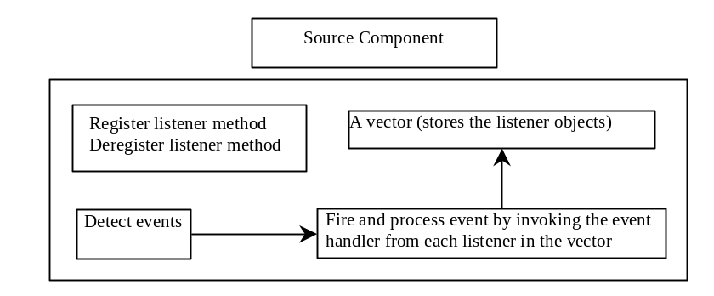

Figure 36.3
The source component detects events and processes them by invoking the event listeners' handlers.

36.4.3 Listener Components
A listener component for an event must implement the event listener interface. The object of the listener component cannot receive event notifications from a source component unless the object is registered as a listener of the source.

A listener component may implement any number of listener interfaces to listen to several types of events. A source component may register many listeners. A source component may register itself as a listener.

Listing 36.1 gives an example that creates a source object (line 8) and a listener object (line 14), and registers the listener with the source object (line 17). Figure 36.4 highlights the relationship between the source and the listener. The listener is registered with the source by invoking the addActionListener method. Once the button is clicked, an ActionEvent is generated by the source. The source object then notifies the listener by invoking the listener’s actionPerformed method.

Listing 36.1 TestSourceListener.java
<margin note line 8: source object>
<margin note line 14: listener object>
<margin note line 17: registration>
<margin note line 22: listener class>

1 import javax.swing.*;
2 import java.awt.event.*;
3
4 public class TestSourceListener {
5 public static void main(String[] args) {
6 JFrame frame = new JFrame("TestSourceListener");
7 // Create a source object
8 JButton jbt = new JButton("OK");
9 frame.add(jbt);
10 frame.setSize(200, 200);
11 frame.setVisible(true);
12
13 // Create a listener
14 MyListener listener = new MyListener();
15
16 // Register a listener
17 jbt.addActionListener(listener);
18 }
19 }
20
21 /** MyListener class */
22 class MyListener implements ActionListener {
23 @Override
24 public void actionPerformed(ActionEvent e) {
25 System.out.println("I will process it!");
26 }
27 }

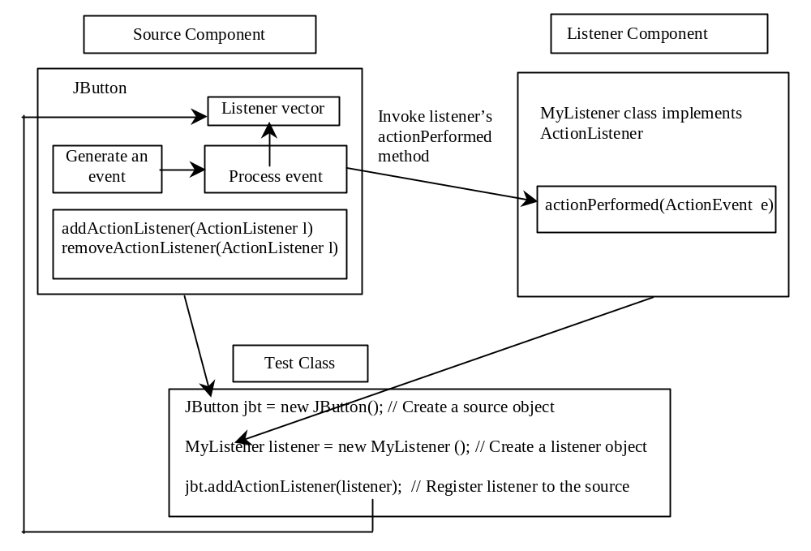

Figure 36.4
The listener is registered with the source, and the source invokes the listener's handler to process the event.

36.5 Creating Custom Source Components

You have used source components such as JButton. This section demonstrates how to create a custom source component.

<margin note: registration method>
A source component must have the appropriate registration and deregistration methods for adding and removing listeners. Events can be unicasted (only one listener object is notified of the event) or multicasted (each object in a list of listeners is notified of the event). The naming pattern for adding a unicast listener is

<margin note: unicast>
public void add<Event>Listener(<Event>Listener l)
throws TooManyListenersException;

The naming pattern for adding a multicast listener is the same, except that it does not throw the TooManyListenersException.

<margin note: multicast>
public void add<Event>Listener(<Event>Listener l)

<margin note: deregistration method>
The naming pattern for removing a listener (either unicast or multicast) is:

public void remove<Event>Listener(<Event>Listener l)

A source component contains the code that creates an event object and passes it to invoke the handler of the listeners. You may use a standard Java event class like ActionEvent to create event objects or may define your own event classes if necessary.

The Course class in Section 10.8, “Case Study: Designing the Course Class,” models the courses. Suppose a Course object fires an ActionEvent when the number of students for the course exceeds a certain enrollment cap. The new class named CourseWithActionEvent is shown in Figure 36.5.

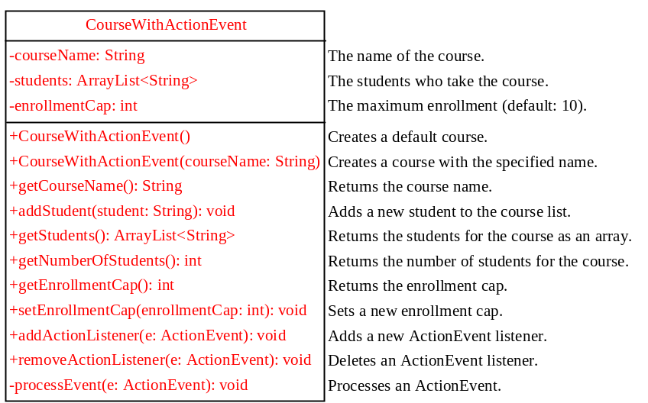

Figure 36.5

The new CourseWithActionEvent class can fire an ActionEvent.

The source component is responsible for registering listeners, creating events, and notifying listeners by invoking the methods defined in the listeners' interfaces. The CourseWithActionEvent component is capable of registering multiple listeners, generating ActionEvent objects when the enrollment exceeds the cap, and notifying the listeners by invoking the listeners' actionPerformed method. Listing 36.2 implements the new class.

Listing 36.2 CourseWithActionEvent.java
<margin note line 6: store students>
<margin note line 7: enrollmentCap>
<margin note line 8: store listeners>
<margin note line 10: no-arg constructor>
<margin note line 13: constructor>
<margin note line 17: return courseName>
<margin note line 23: create event>
<margin note line 46: register listener>
<margin note line 58: remove listener>
<margin note line 67: process event>
Top of Form

Bottom of Form

1 import java.util.*;
2 import java.awt.event.*;
3
4 public class CourseWithActionEvent {
5 private String courseName = "default name";
6 private ArrayList<String> students = new ArrayList<String>();
7 private int enrollmentCap = 10;
8 private ArrayList<ActionListener> actionListenerList;
9
10 public CourseWithActionEvent() {
11 }
12
13 public CourseWithActionEvent(String courseName) {
14 this.courseName = courseName;
15 }
16
17 public String getCourseName() {
18 return courseName;
19 }
20
21 public void addStudent(String student) {
22 if (students.size() >= enrollmentCap) // Fire ActionEvent
23 processEvent(new ActionEvent(this,
24 ActionEvent.ACTION_PERFORMED, null));
25 else
26 students.add(student);
27 }
28
29 public ArrayList<String> getStudents() {
30 return students;
31 }
32
33 public int getNumberOfStudents() {
34 return students.size();
35 }
36
37 public int getEnrollmentCap() {
38 return enrollmentCap;
39 }
40
41 public void setEnrollmentCap(int enrollmentCap) {
42 this.enrollmentCap = enrollmentCap;
43 }
44
45 /** Register an action event listener */
46 public synchronized void addActionListener
47 (ActionListener listener) {
48 if (actionListenerList == null) {
49 actionListenerList = new ArrayList<ActionListener>(2);
50 }
51
52 if (!actionListenerList.contains(listener)) {
53 actionListenerList.add(listener);
54 }
55 }
56
57 /** Remove an action event listener */
58 public synchronized void removeActionListener
59 (ActionListener listener) {
60 if (actionListenerList !=
61 null && actionListenerList.contains(listener)) {
62 actionListenerList.remove(listener);
63 }
64 }
65
66 /** Fire ActionEvent */
67 private void processEvent(ActionEvent e) {
68 ArrayList<ActionListener> list;
69
70 synchronized (this) {
71 if (actionListenerList == null) return;
72 list = (ArrayList<ActionListener>)actionListenerList.clone();
73 }
74
75 for (int i = 0; i < list.size(); i++) {
76 ActionListener listener = (ActionListener)list.get(i);
77 listener.actionPerformed(e);
78 }
79 }
80 }

Since the source component is designed for multiple listeners, a java.util.ArrayList instance actionListenerList is used to hold all the listeners for the source component (line 8). The data type of the elements in the array list is ActionListener. To add a listener, listener, to actionListenerList, use

actionListenerList.add(listener); (line 53)

To remove a listener, listener, from actionListenerList, use

actionListenerList.remove(listener); (line 62)

The if statement (lines 52–53) ensures that the addActionListener method does not add the listener twice if it is already in the list. The removeActionListener method removes a listener if it is in the list. actionListenerList is an instance of ArrayList, which functions as a flexible array that can grow or shrink dynamically. Initially, actionListenerList is of size 2, but the capacity can be changed dynamically. If more than two listeners are added to actionListenerList, the list size will be automatically increased.

NOTE
<margin note: storing listeners>
Instead of using ArrayList, you can also use javax.swing.event.EventListenerList to store listeners. Using EventListenerList is preferred, since it provides the support for synchronization and is efficient in the case of no listeners.

The addActionListener and removeActionListener methods are synchronized to prevent data corruption on actionListenerList when attempting to register multiple listeners concurrently (lines 46, 58).

The addStudent method (lines 21-27) checks whether the number of students is more than the enrollment cap. If so, it creates an ActionEvent and invokes the processEvent method to process the event (lines 23–24). If not, add a new student to the course (line 26).

The UML diagram for ActionEvent is shown in Figure 36.2. To create an ActionEvent, use the constructor

ActionEvent(Object source, int id, String command)

where source specifies the source component, id identifies the event, and command specifies a command associated with the event. Use ActionEvent.ACTION_PERFORMED for the id. If you don’t want to associate a command with the event, use null.

The processEvent method (lines 67–79) is invoked when an ActionEvent is generated. This notifies the listeners in actionListenerList by calling each listener's actionPerformed method to process the event. It is possible that a new listener may be added or an existing listener may be removed when processEvent is running. To avoid corruption on actionListenerList, a clone list of actionListenerList is created for use to notify listeners. To avoid corruption when creating the clone, invoke it in a synchronized block, as in lines 70–73:

synchronized (this) {

if (actionListenerList == null) return;

list = (ArrayList)actionListenerList.clone();

}

Listing 36.3 gives a test program that creates a course using the new class (line 5), sets the enrollment cap to 2 (line 8), registers a listener (line 9), and adds three students to the course (lines 11-13). When line 13 is executed, the addStudent method adds student Tim to the course and fires an ActionEvent because the course exceeds the enrollment cap. The course object invokes the listener’s actionPerformed method to process the event and displays a message Enrollment cap exceeded.

Listing 36.3 TestCourseWithActionEvent.java
<margin note line 5: create course>
<margin note line 8: set enrollmentCap>
<margin note line 9: create listener>
<margin note line 10: register listener>
<margin note line 11: add students>

1 import java.awt.event.*;
2
3 public class TestCourseWithActionEvent {
4 CourseWithActionEvent course =
5 new CourseWithActionEvent("Java Programming");
6
7 public TestCourseWithActionEvent() {
8 course.setEnrollmentCap(2);
9 ActionListener listener = new Listener();
10 course.addActionListener(listener);
11 course.addStudent("John");
12 course.addStudent("Jim");
13 course.addStudent("Tim");
14 }
15
16 public static void main(String[] args) {
17 new TestCourseWithActionEvent();
18 }
19
20 private class Listener implements ActionListener {
21 @Override
22 public void actionPerformed(ActionEvent e) {
23 System.out.println("Enrollment cap exceeded");
24 }
25 }
26 }

The flow of event processing from the source to the listener is shown in Figure 36.6.

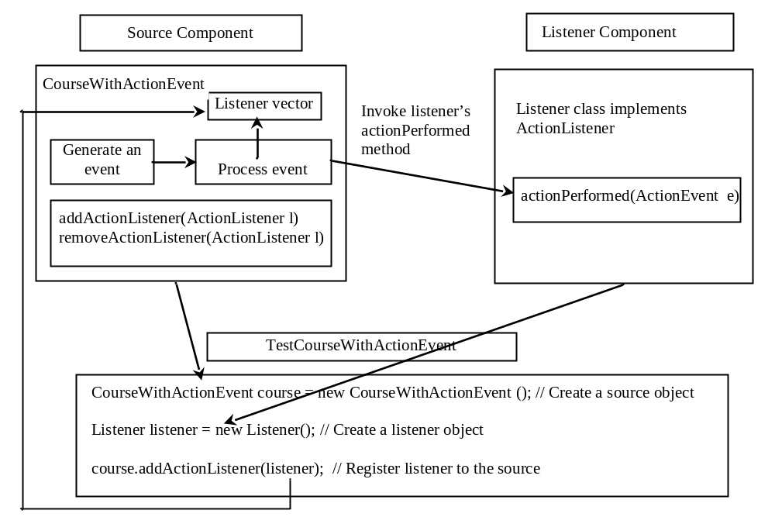

Figure 36.6
The listener is registered with the source course, and the source invokes the listener's handler actionPerformed to process the event.

36.6 Creating Custom Event Sets
The Java API provides many event sets. You have used the event set ActionEvent/ActionListener in the preceding section. A course object fires an ActionEvent when the enrollment cap is exceeded. It is convenient to use the existing event sets in the Java API, but they are not always adequate. Sometimes you need to define custom event classes in order to obtain information not available in the existing API event classes. For example, suppose you want to know the enrollment cap and the number of students in the course; an ActionEvent object does not provide such information. You have to define your own event class and event listener interface.

A custom event class must extend java.util.EventObject or a subclass of java.util.EventObject. Additionally, it may provide constructors to create events, data members, and methods to describe events.

A custom event listener interface must extend java.util.EventListener or a subinterface of java.util.EventListener and define the signature of the handlers for the event. By convention, the listener interface should be named XListener for the corresponding event class named XEvent. For example, ActionListener is the listener interface for ActionEvent.

Let us define EnrollmentEvent as the event class for describing the enrollment event and its corresponding listener interface EnrollmentListener for defining an enrollmentExceeded handler, as shown in Figure 36.7. The getStudentToEnroll() method returns the student who attempts to enroll the course.

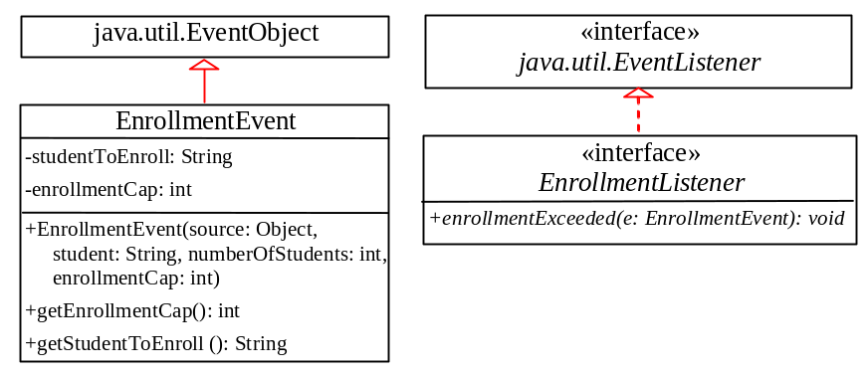

Figure 36.7
EnrollmentEvent and EnrollmentListener comprise an event set for enrollment event.

The source code for the enrollment event set is given in Listings 36.4 and 36.5.

Listing 36.4 EnrollmentEvent.java
<margin note line 1: extends EventObject>
<margin note line 6: constructor>
<margin note line 8: invoke superclass constructor>

1 public class EnrollmentEvent extends java.util.EventObject {
2 private String studentToEnroll;
3 private int enrollmentCap;
4
5 /** Construct a EnrollmentEvent */
6 public EnrollmentEvent(Object source, String studentToEnroll,
7 int enrollmentCap) {
8 super(source);
9 this.studentToEnroll = studentToEnroll;
10 this.enrollmentCap = enrollmentCap;
11 }
12
13 public String getStudentToEnroll() {
14 return studentToEnroll;
15 }
16
17 public long getEnrollmentCap() {
18 return enrollmentCap;
19 }
20 }

Listing 36.5 EnrollmentListener.java
<margin note line 1: extends EventListener>
<margin note line 3: handler>

1 public interface EnrollmentListener extends java.util.EventListener {
2 /** Handle an EnrollemntEvent, to be implemented by a listener */
3 public void enrollmentExceeded(EnrollmentEvent e);
4 }

An event class is an extension of EventObject. To construct an event, the constructor of EventObject must be invoked by passing a source object as the argument. In the constructor for EnrollmentEvent, super(source) (line 8) invokes the superclass’s constructor with the source object as the argument. EnrollmentEvent contains the information pertaining to the event, such as number of students and enrollment cap.

EnrollmentListener simply extends EventListener and defines the enrollmentExceeded method for handling enrollment events.

NOTE
<margin note: specifying a source for an event>
An event class does not have a no-arg constructor, because you must always specify a source for the event when creating an event.
Let us revise CourseWithActionEvent in Listing 36.2 to use EnrollmentEvent/EnrollmentListener instead of ActionEvent/ActionListener. The new class named CouseWithEnrollmentEvent in Listing 36.6 is very similar to CourseWithActionEvent in Listing 36.2.

Listing 36.6 CourseWithEnrollmentEvent.java
<margin note line 5: store students>
<margin note line 6: enrollmentCap>
<margin note line 8: store listeners>
<margin note line 10: no-arg constructor>
<margin note line 13: constructor>
<margin note line 22: create event>
<margin note line 45: register listener>
<margin note line 57: remove listener>
<margin note line 66: process event>

1 import java.util.*;
2
3 public class CourseWithEnrollmentEvent {
4 private String courseName = "default name";
5 private ArrayList<String> students = new ArrayList<String>();
6 private int enrollmentCap = 10;
7 private ArrayList<EnrollmentListener> enrollmentListenerList;
8
9 public CourseWithEnrollmentEvent() {
10 }
11
12 public CourseWithEnrollmentEvent(String courseName) {
13 this.courseName = courseName;
14 }
15
16 public String getCourseName() {
17 return courseName;
18 }
19
20 public void addStudent(String student) {
21 if (students.size() == enrollmentCap) // Fire EnrollmentEvent
22 processEvent(new EnrollmentEvent(this,
23 student, enrollmentCap));
24 else
25 students.add(student);
26 }
27
28 public ArrayList<String> getStudents() {
29 return students;
30 }
31
32 public int getNumberOfStudents() {
33 return students.size();
34 }
35
36 public int getEnrollmentCap() {
37 return enrollmentCap;
38 }
39
40 public void setEnrollmentCap(int enrollmentCap) {
41 this.enrollmentCap = enrollmentCap;
42 }
43
44 /** Register an action event listener */
45 public synchronized void addEnrollmentListener
46 (EnrollmentListener listener) {
47 if (enrollmentListenerList == null) {
48 enrollmentListenerList = new ArrayList<EnrollmentListener>(2);
49 }
50
51 if (!enrollmentListenerList.contains(listener)) {
52 enrollmentListenerList.add(listener);
53 }
54 }
55
56 /** Remove an action event listener */
57 public synchronized void removeEnrollmentListener
58 (EnrollmentListener listener) {
59 if (enrollmentListenerList !=
60 null && enrollmentListenerList.contains(listener)) {
61 enrollmentListenerList.remove(listener);
62 }
63 }
64
65 /** Fire EnrollmentEvent */
66 private void processEvent(EnrollmentEvent e) {
67 ArrayList<EnrollmentListener> list;
68
69 synchronized (this) {
70 if (enrollmentListenerList == null) return;
71 list = (ArrayList<EnrollmentListener>)
72 enrollmentListenerList.clone();
73 }
74
75 for (int i = 0; i < list.size(); i++) {
76 EnrollmentListener listener = (EnrollmentListener)list.get(i);
77 listener.enrollmentExceeded(e);
78 }
79 }
80 }

Line 8 creates a java.util.ArrayList instance enrollmentListenerList for holding all the listeners for the source component. The data type of the elements in the array list is EnrollmentListener. The registration and deregistration methods for EnrollmentListener are defined in lines 45, 57.

The addStudent method checks whether the number of students is more than the enrollment cap. If so, it creates an EnrollmentEvent and invokes the processEvent method to process the event (lines 22–23). If not, add a new student to the course (line 25).

To create an EnrollmentEvent, use the constructor

EnrollmentEvent(Object source, String studentToEnroll,

int enrollmentCap)

where source specifies the source component.

The processEvent method (lines 66–78) is invoked when an EnrollmentEvent is generated. This notifies the listeners in enrollmentListenerList by calling each listener's enrollmentExceeded method to process the event.

Let us revise the test program in Listing 36.3 to use EnrollmentEvent/EnrollmentListener instead of ActionEvent/ActionListener. The new program, given in Listing 36.7, creates a course using CourseWithEnrollmentEvent (line 3), sets the enrollment cap to 2 (line 6), creates an enrollment listener (line 7), registers it (line 8), and adds three students to the course (lines 9–11). When line 11 is executed, the addStudent method adds student Tim to the course and fires an EnrollmentEvent because the course exceeds the enrollment cap. The course object invokes the listener’s enrollmentExceeded method to process the event and displays the number of students in the course and the enrollment cap.

Listing 36.7 TestCourseWithEnrollmentEvent.java
<margin note line 3: create course>
<margin note line 6: set enrollmentCap>
<margin note line 7: create listener>
<margin note line 8: register listener>
<margin note line 9: add students>

1 public class TestCourseWithEnrollmentEvent {
2 CourseWithEnrollmentEvent course =
3 new CourseWithEnrollmentEvent("Java Programming");
4
5 public TestCourseWithEnrollmentEvent() {
6 course.setEnrollmentCap(2);
7 EnrollmentListener listener = new NewListener();
8 course.addEnrollmentListener(listener);
9 course.addStudent("John Smith");
10 course.addStudent("Jim Peterson");
11 course.addStudent("Tim Johnson");
12 }
13
14 public static void main(String[] args) {
15 new TestCourseWithEnrollmentEvent();
16 }
17
18 private class NewListener implements EnrollmentListener {
19 public void enrollmentExceeded(EnrollmentEvent e) {
20 System.out.println(e.getStudentToEnroll() + " attempted to "
21 + "enroll. The enrollment cap is " + e.getEnrollmentCap());
22 }
23 }
24 }

<Output>

Tim Johnson attempted to enroll

The enrollment cap is 2
<End Output>

The flow of event processing from the source to the listener is shown in Figure 36.8.

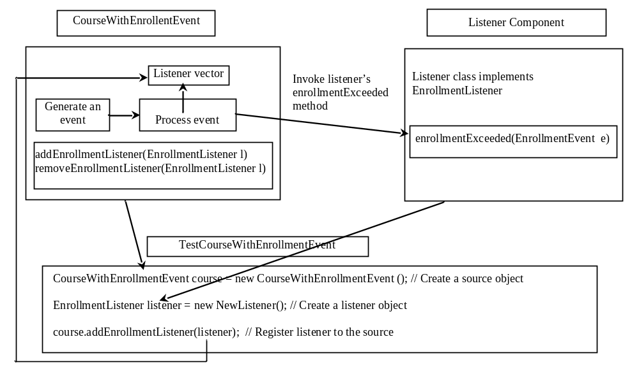

Figure 36.8
The listener is registered with the source course, and the source invokes the listener's handler enrollmentExceeded to process the event.

TIP
<margin note: ActionEvent>
Using the ActionEvent/ActionListener event set is sufficient in most cases. Normally, the information about the event can be obtained from the source. For example, the number of students in the course and the enrollment can all be obtained from a course object. The source can be obtained by invoking e.getSource() for any event e.

NOTE
<margin note: inheriting features>
The EnrollmentEvent component is created from scratch. If you build a new component that extends a component capable of generating events, the new component inherits the ability to generate the same type of events. For example, since JButton is a subclass of java.awt.Component that can fire MouseEvent, JButton can also detect and generate mouse events. You don't need to write the code to generate these events and register listeners for them, since the code is already given in the superclass. However, you still need to write the code to make your component capable of firing events not supported in the superclass.

Key Terms

- event set
- JavaBeans component
- JavaBeans events
- JavaBeans properties

Chapter Summary
- JavaBeans is a software component architecture that extends the power of the Java language for building reusable software components. JavaBeans properties describe the state of the bean. Naturally, data fields are used to store properties. However, a bean property is not necessarily a data field.
- A source component must have the appropriate registration and deregistration methods for adding and removing listeners. Events can be unicasted (only one listener object is notified of the event) or multicasted (each object in a list of listeners is notified of the event).
- An event object is created using an event class, such as ActionEvent, MouseEvent, and ItemEvent. All event classes extend java.util.EventObject. Every event class is associated with an event listener interface that defines one or more methods referred to as handlers. An event listener interface is a subinterface of java.util.EventListener. Since an event class and its listener interface are coexistent, they are often referred to as an event set or event pair.

Test Questions
Do the test questions for this chapter online at www.cs.armstrong.edu/liang/intro9e/test.html.

Review Questions

Sections 36.1-36.4

36.1
What is a JavaBeans component? Is every GUI class a JavaBeans component? Is every GUI user interface component a JavaBeans component? Is it true that a JavaBeans component must be a GUI user interface component?

36.2
Describe the naming conventions for accessor and mutator methods in a JavaBeans component.

36.3
Describe the naming conventions for JavaBeans registration and deregistration methods.

36.4
What is an event pair? How do you define an event class? How do you define an event listener interface?

Programming Exercises

Sections 36.1-36.6
36.1*
(Enable MessagePanel to fire ActionEvent) The MessagePanel class in Listing 15.7 is a subclass of JPanel; it can fire a MouseEvent, KeyEvent, and ComponentEvent, but not an ActionEvent. Modify the MessagePanel class so that it can fire an ActionEvent when an instance of the MessagePanel class is clicked. Name the new class MessagePanelWithActionEvent. Test it with a Java applet that displays the current time in a message panel whenever the message panel is clicked, as shown in Figure 36.9.

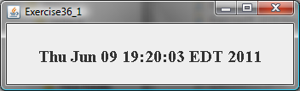

Figure 36.9

The current time is displayed whenever you click on the message panel.

36.2*
(Create custom event sets and source components) Develop a project that meets the following requirements:
- Create a source component named MemoryWatch for monitoring memory. The component generates a MemoryEvent when the free memory space exceeds a specified highLimit or is below a specified lowLimit. The highLimit and lowLimit are customizable properties in MemoryWatch.
- Create an event set named MemoryEvent and MemoryListener. The MemoryEvent simply extends java.util.EventObject and contains two methods, freeMemory and totalMemory, which return the free memory and total memory of the system. The MemoryListener interface contains two handlers, sufficientMemory and insufficientMemory. The sufficientMemory method is invoked when the free memory space exceeds the specified high limit, and insufficientMemory is invoked when the free memory space is less than the specified low limit. The free memory and total memory in the system can be obtained using

Runtime runtime = Runtime.getRuntime();
runtime.freeMemory();
runtime.totalMemory();

- Develop a listener component that displays free memory, total memory, and whether the memory is sufficient or insufficient when a MemoryEvent occurs. Make the listener an applet with a main method to run standalone.

36.3**
(The Hurricane source component) Create a class named Hurricane with properties name and category and its accessor methods. The Hurricane component generates an ActionEvent whenever its category property is changed. Write a listener that displays the hurricane category. If the category is 2 or greater, a message “Hurricane Warning!!!” is displayed, as shown in Figure 36.10.

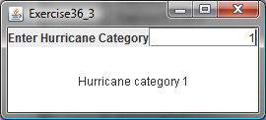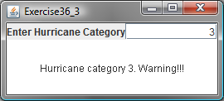

Figure 36.10
Whenever the hurricane category is changed, an appropriate message is displayed in the message panel.

36.4**
(The Clock source component) Create a JavaBeans component for displaying an analog clock. This bean allows the user to customize a clock through the properties, as shown in Figure 36.11. Write a test program that displays four clocks, as shown in Figure 36.12.

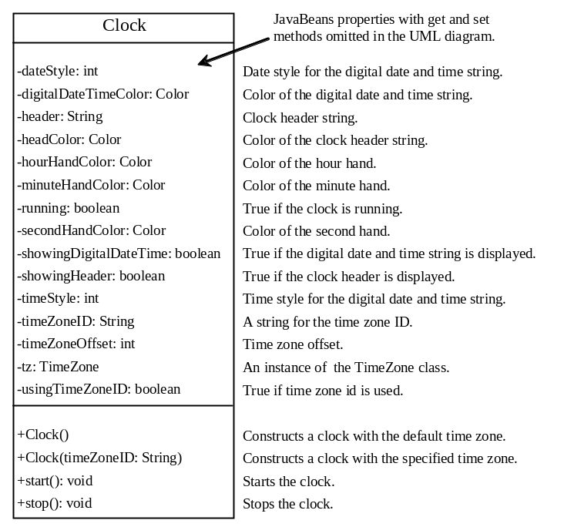

Figure 36.11

The Clock component displays an analog clock.

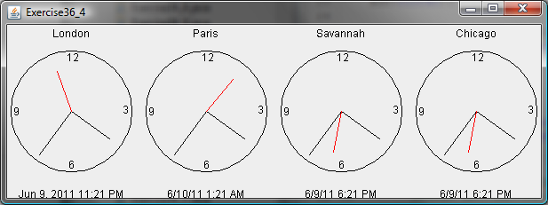

Figure 36.12

The program displays six clocks using the Clock component.

36.5*
(Create ClockWithAlarm from Clock) Create an alarm clock, named ClockWithAlarm, which extends the Clock component built in the preceding exercise, as shown in Figure 36.13. This component contains two new properties, alarmDate and alarmTime. alarmDate is a string consisting of year, month, and day, separated by commas. For example, 1998,5,13 represents the year 1998, month 5, and day 13. alarmTime is a string consisting of hour, minute, and second, separated by commas. For example, 10,45,2 represents 10 o’clock, 45 minutes, and 2 seconds. When the clock time matches the alarm time, ClockWithAlarm fires an ActionEvent. Write a test program that displays the alert message “You have an appointment now” on a dialog box at a specified time (e.g., date: 2004,1,1 and time: 10,30,0).

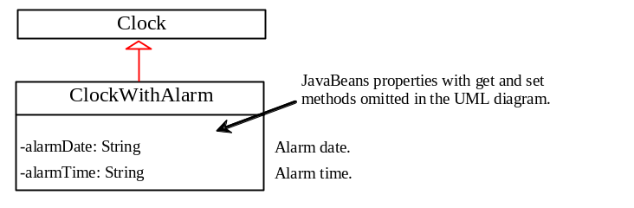

Figure 36.13

The ClockWithAlarm component extends Clock with alarm functions.

36.6***
(The Tick source component) Create a custom source component that is capable of generating tick events at variant time intervals, as shown in Figure 36.14. The Tick component is similar to javax.swing.Timer. The Timer class generates a timer at fixed time intervals. This Tick component can generate tick events at variant as well as at fixed time intervals.

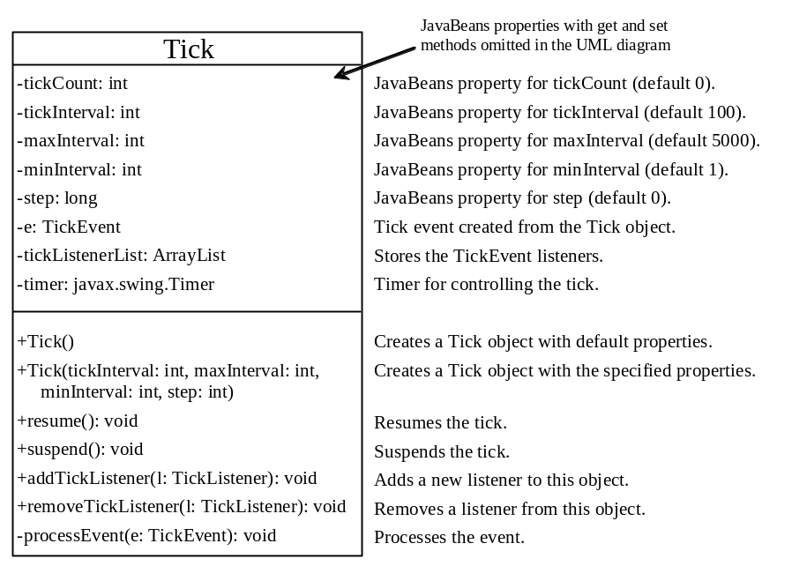

Figure 36.14

Tick is a component that generates TickEvent.

The component contains the properties tickCount, tickInterval, maxInterval, minInterval, and step. The component adjusts the tickInterval by adding step to it after a tick event occurs. If step is 0, tickInterval is unchanged. If step > 0, tickInterval is increased. If step < 0, tickInterval is decreased. If tickInterval > maxInterval or tickInterval < minInterval, the component will no longer generate tick events.

The Tick component is capable of registering multiple listeners, generating TickEvent objects at variant time intervals, and notifying the listeners by invoking the listeners' handleTick method. The UML diagram for TickEvent and TickListener is shown in Figure 36.15.

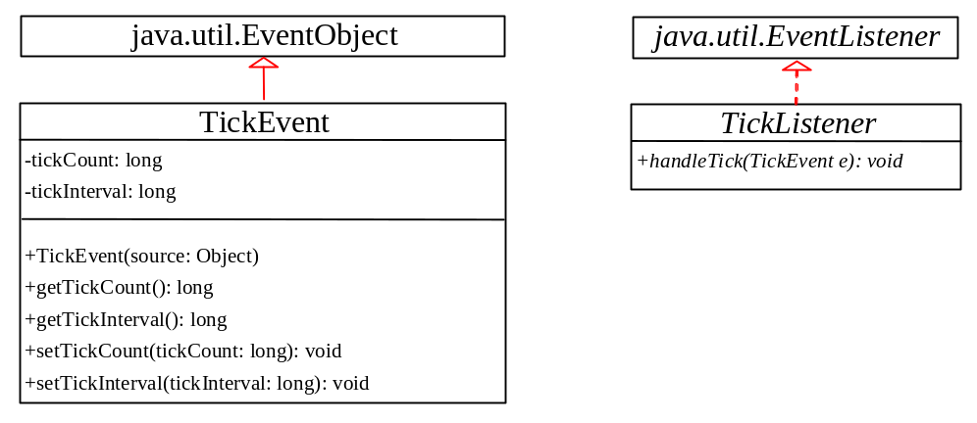

Figure 36.15

TickEvent and TickListener comprise an event set for a tick event.

Create an applet named DisplayMovingMessage, and create a panel named MovingMessage to display the message. Place an instance of the panel in the applet. To enable the message to move rightward, redraw the message with a new incremental x-coordinate. Use a Tick object to generate a tick event and invoke the repaint method to redraw the message when a tick event occurs. To move the message at a decreasing pace, use a positive step (e.g., 10) when constructing a Tick object.

